Report

Laboratory Work 2

Dmitry Ladutsko

August 26, 2022

# 1. Developing Integration Services Solutions

# **1.1. Exercise 1: Creating an Integration Services Project and implementing a package**

The Marketing department has requested a list of products from the Adventure Works database. They want the list in the format of a comma-delimited text file. The file must include all columns from the products table. You also want to view the number of rows returned each time you generate the file so the package should have a variable which stores the number of exported rows. The package must send an e-mail message after the Products.txt file is created (using event handler). The body of the message should contain the total number of rows which have been exported.

**Result:** SSIS solution and the output file (Product.txt).

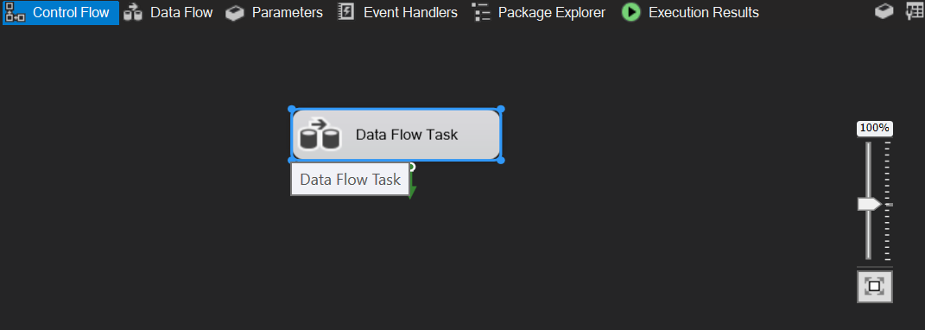

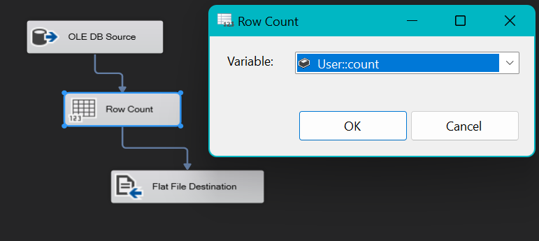

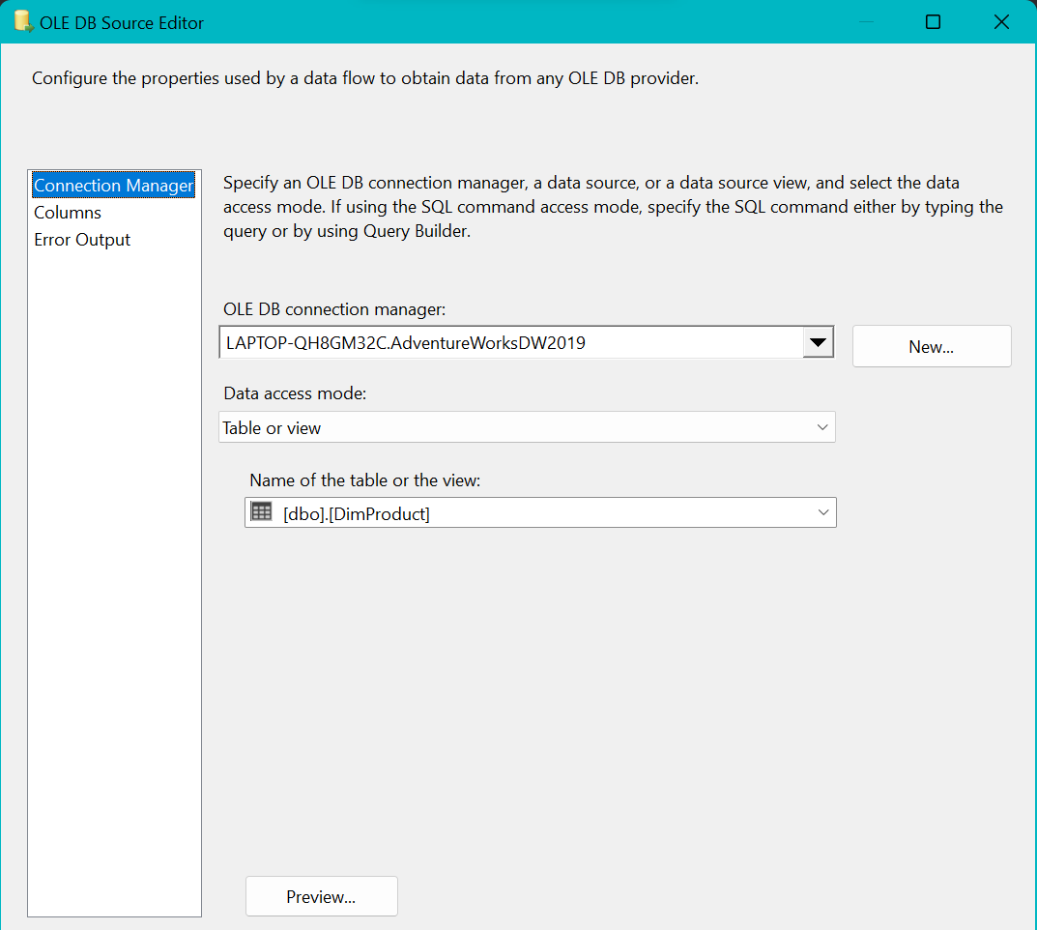

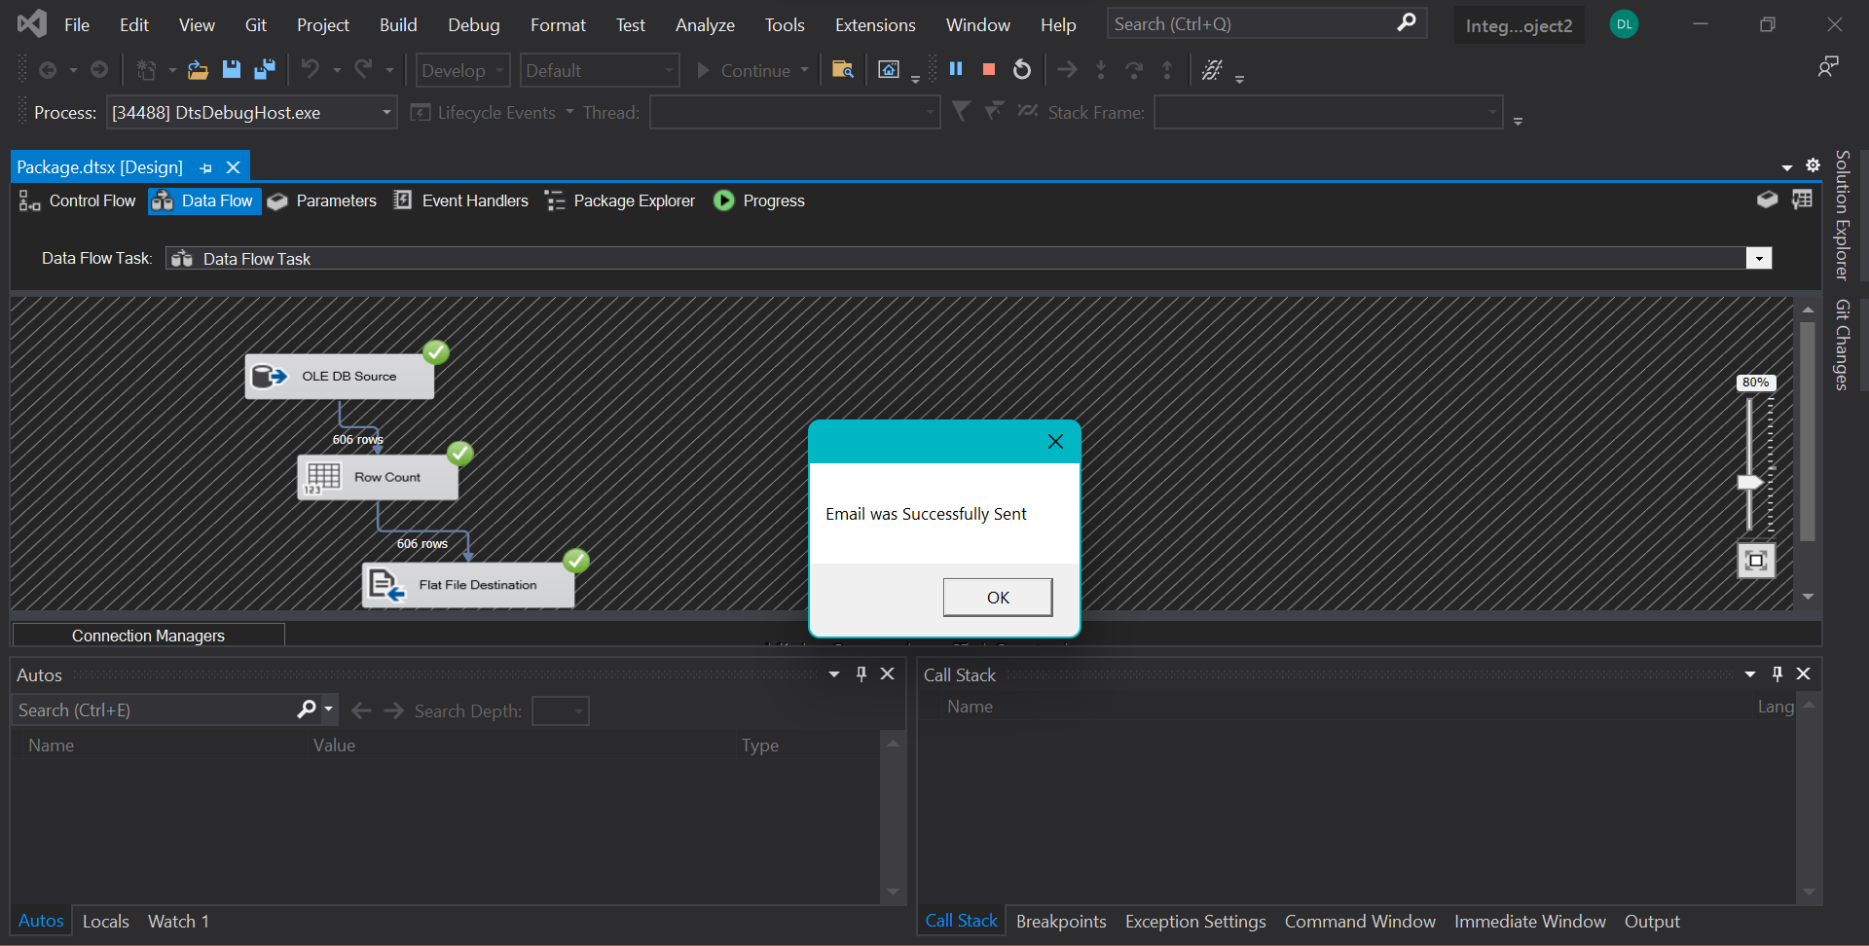

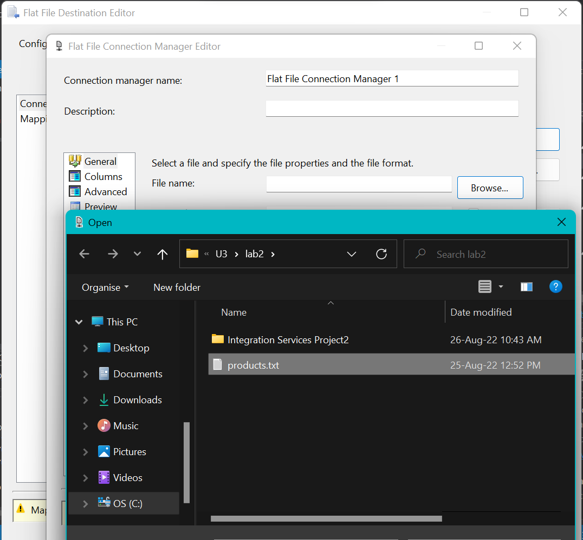

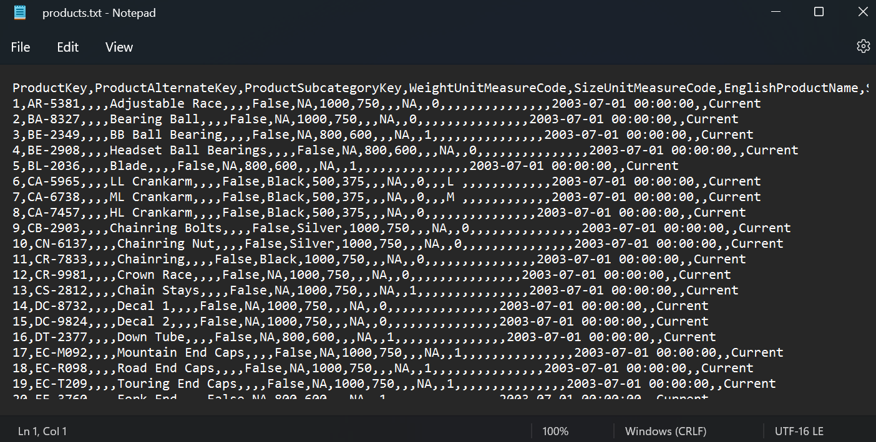

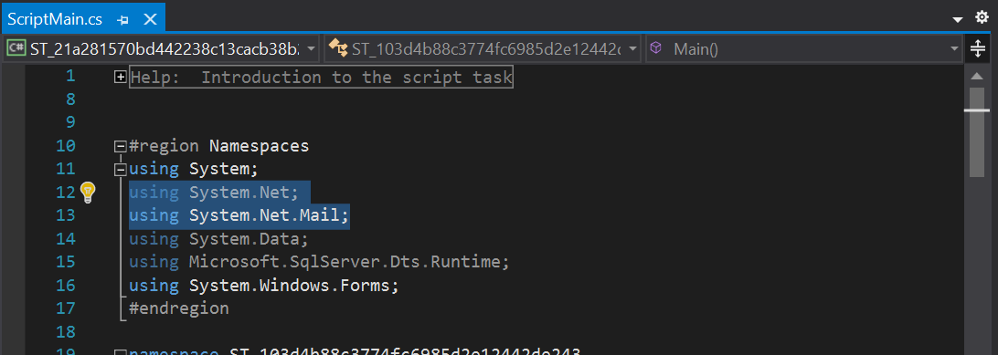

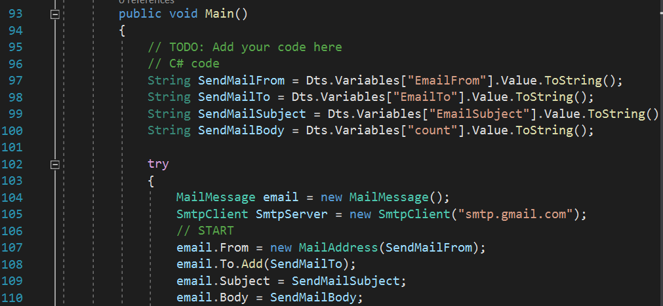

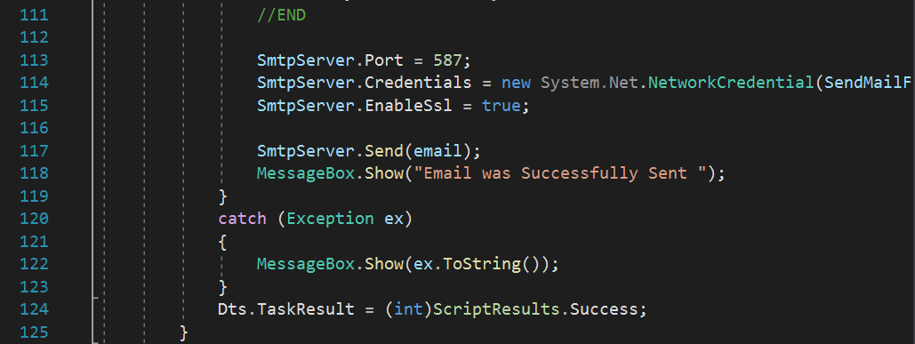

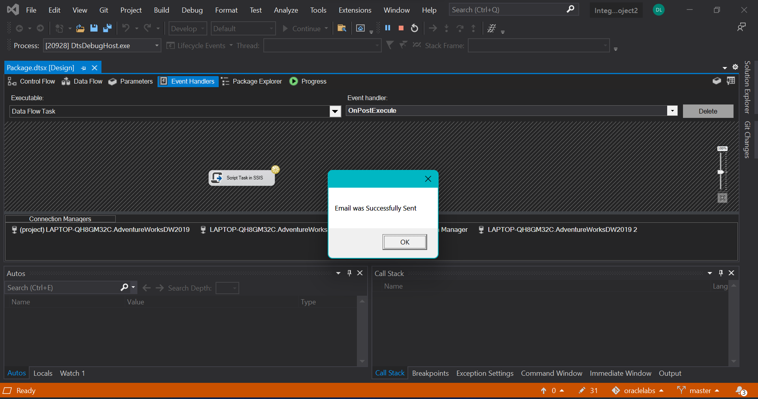

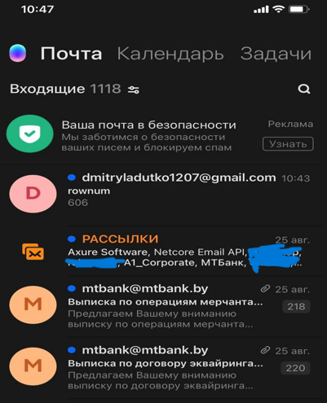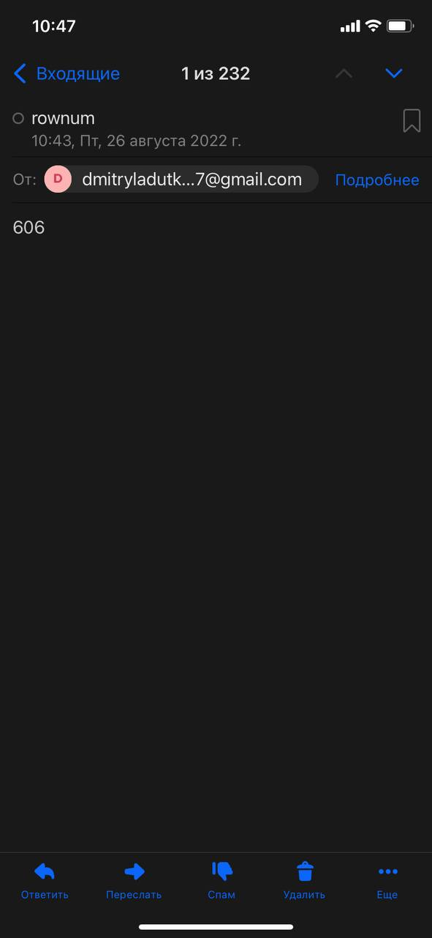

# **1.2. Exercise 2: Creating a package to keep list of files from a directory**

You need to create SSIS package that reads all file names from a directory (which is a parameter for the package) and saves them to a table in the database. The table should include at least two columns:

ID – Unique Id for a file

FileFullPath – Full path for a file

ID column should be generated in SSIS package (using sequences on DB level is not allowed)

Additionally, you can add column CreationTime. This is not obligatory but you will get +1 bonus point if you find how to populate it.

**Result:** SSIS solution and the package.

***Note.*** Let’s create table for storing ID, FileFullPath, CreationTime of files

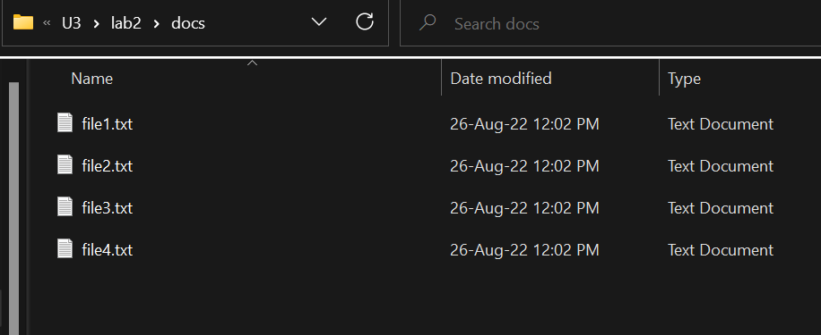

***Note.*** I created 4 .txt files to later take their file paths and insert them into table

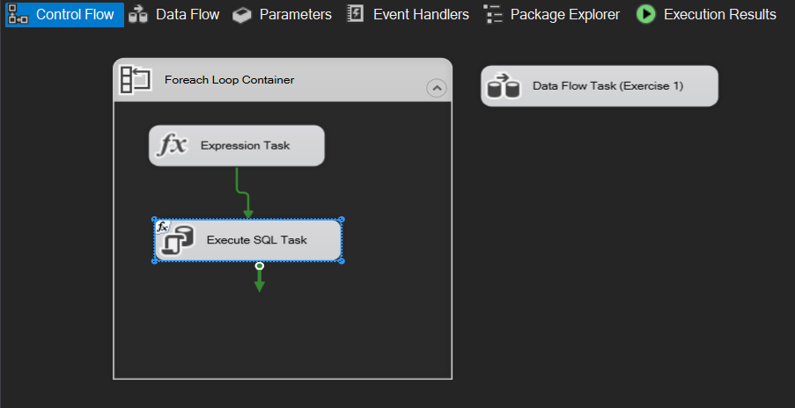

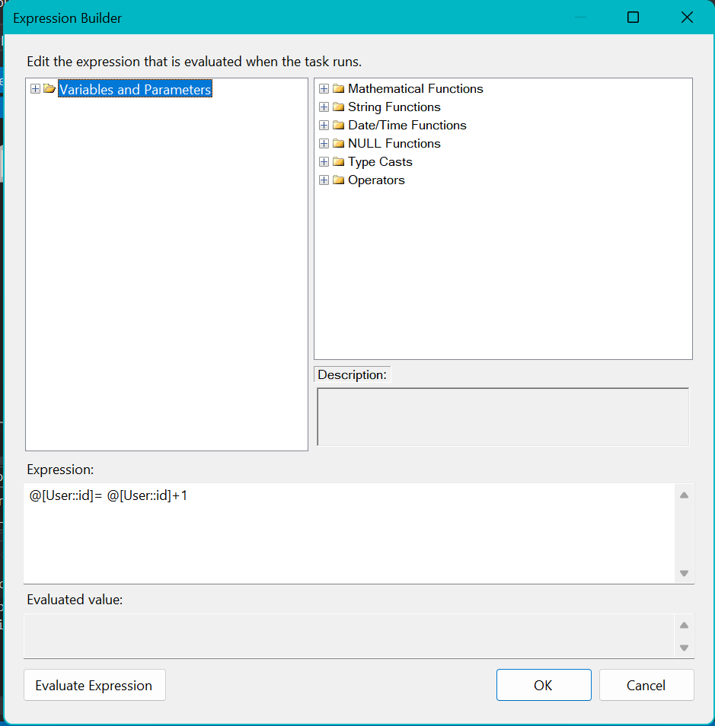 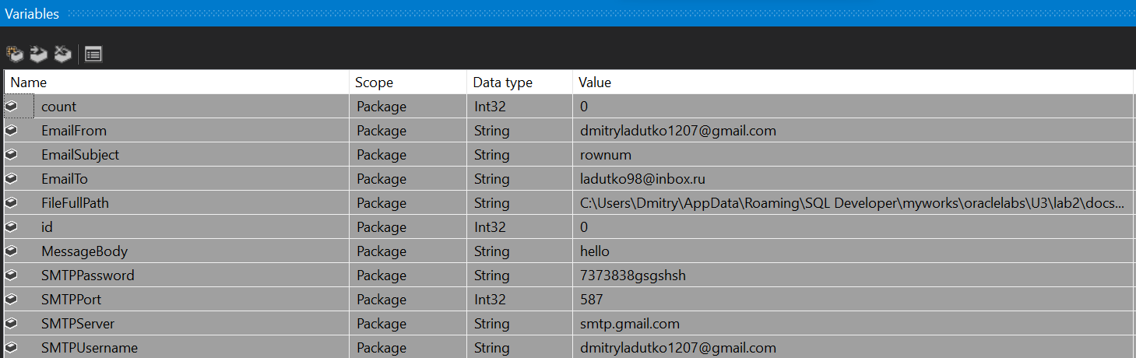

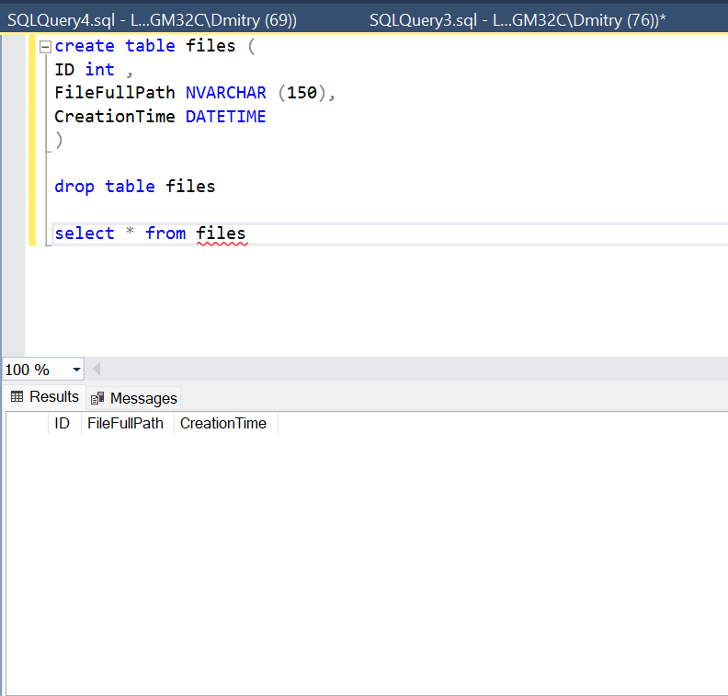

***Note.*** As you can see we created table with 3 colums consists of id, file path and **creating time.** As it said in exercise I did not use sequences on DB level to auto – increment ID column values. I specified it in Expression task the way theat every loop I increment id value and store the new value in ID variable.

For insearting creation time I used GETDATE() system function and created column in file table of DATETIME type

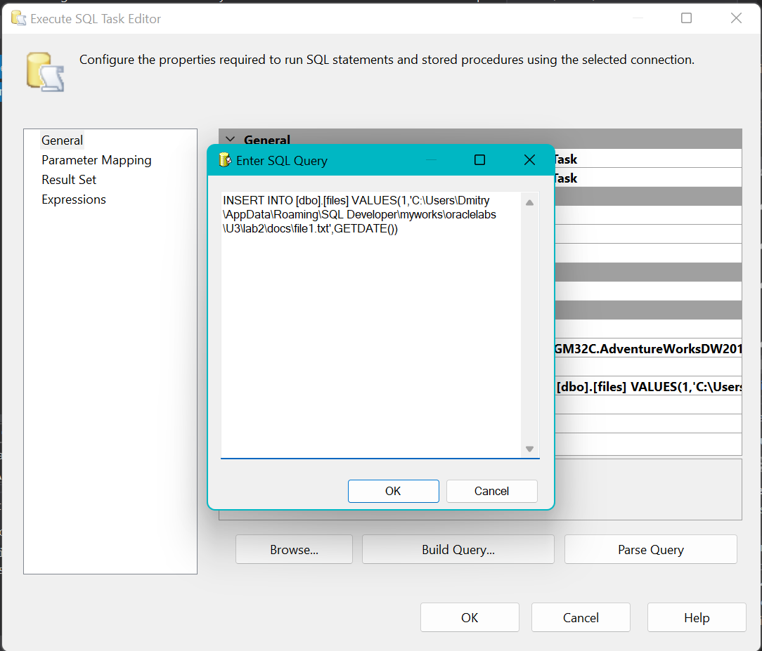

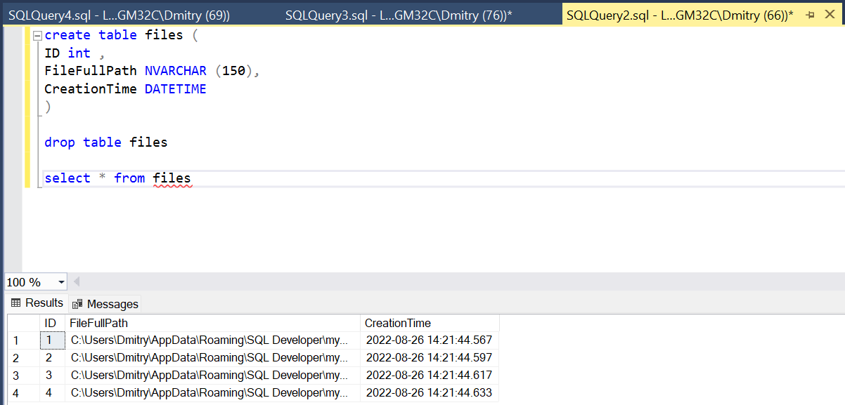

**Laboratory Work Summary**

**At this Laboratory Work** we practiced how we can count number of rows, send notifications **using C# code** to later use it for some periodic alerts. Practiced how we can use **for each loop containers**, how we can realise **sequences** using not only **SQL script**, but also do it in **SSIS package**, how we can **extract filename** from folder to load it into source files table.

We also **repeated** how we can **transform** SQL tables into **comma – delimited text**.